**2017 UC MIDTERM RESULTS**

Adams House

1) Anna Wechsler

2) Ryan Sim

Cabot House

1) Saim Raza

Currier House

1) Anna Raheem

Kirkland House

1) Sophie Mehta

2) Mai-Linh Ton

Lowell House

1) Berkeley Brown

2) Samarth Gupta

Pforzheimer House

1) Osama Arif

Quincy House

1) Garrett Wen

Winthrop House

1) Ben Griswold

Elm Yard

1) Salma Abdelrahman

**ADAMS**

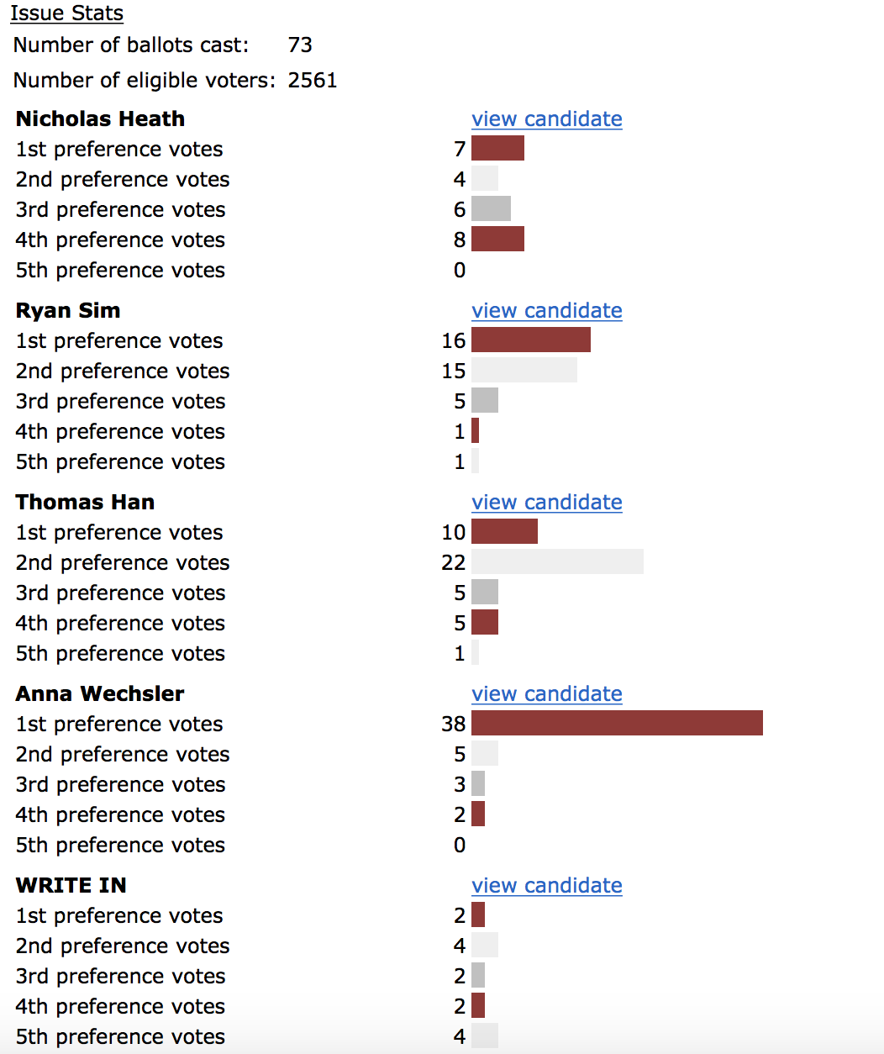

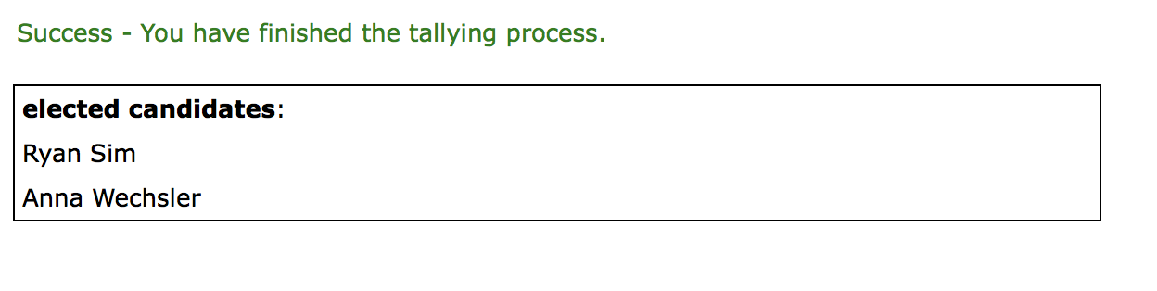

**CABOT**

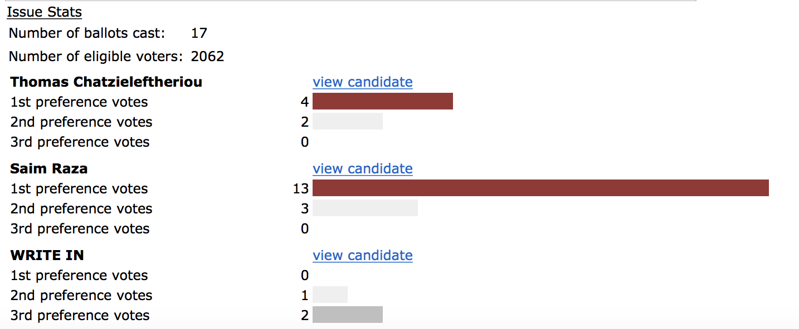

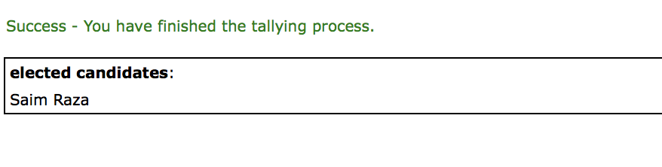

**CURRIER**

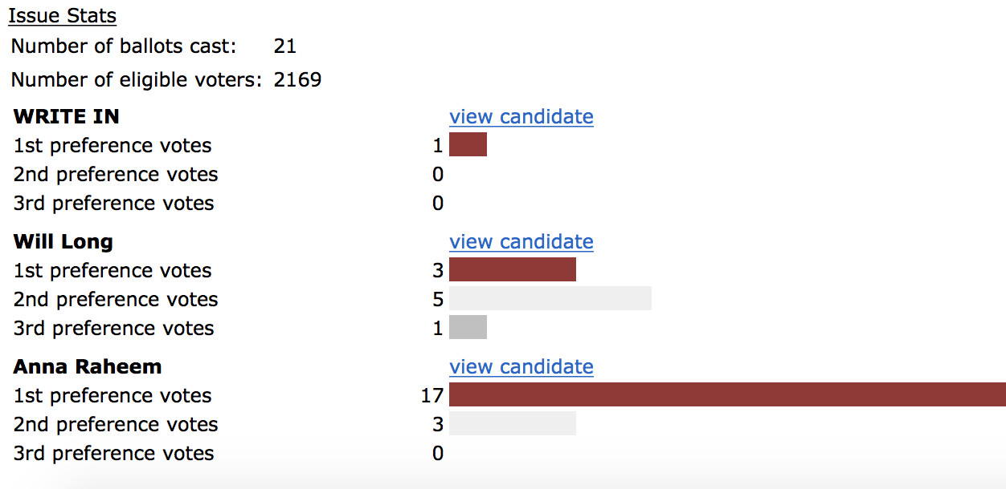

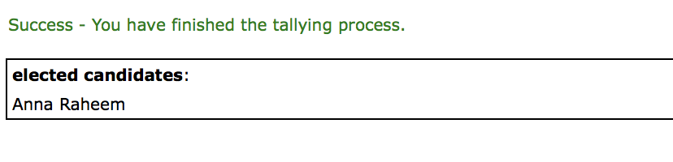

**KIRKLAND**

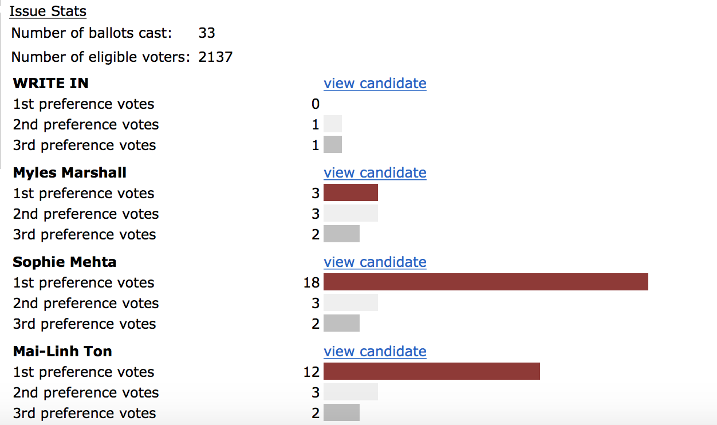

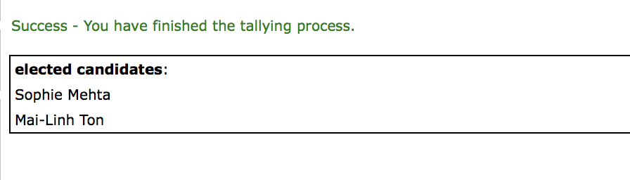

**LOWELL**

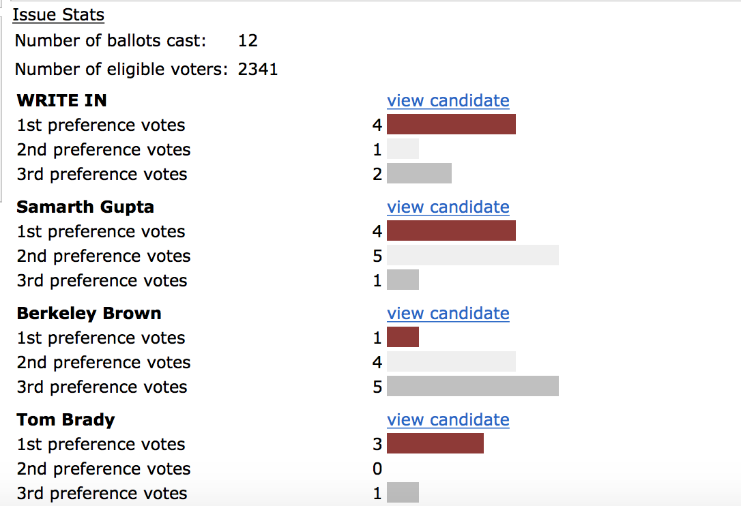

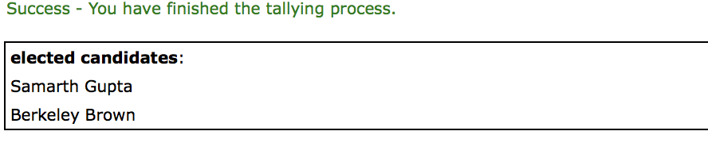

NOTE: “Tom Brady” is not a registered Harvard undergraduate and is, therefore, ineligible to be elected.

**PFOHO**

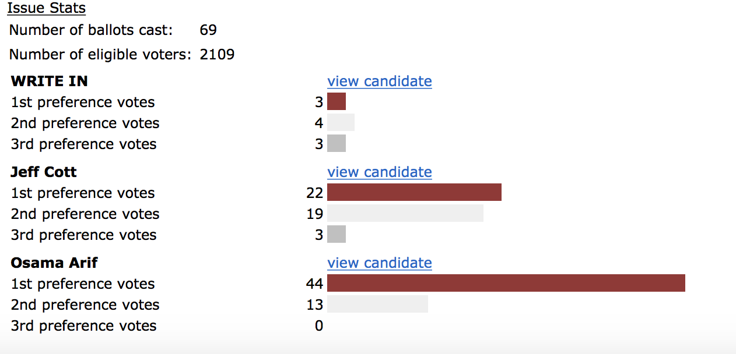

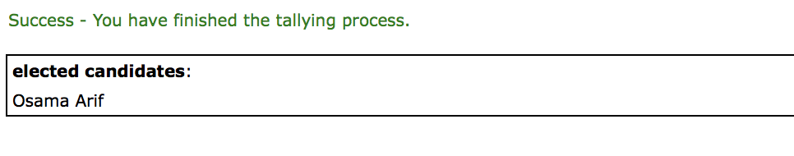

**QUINCY**

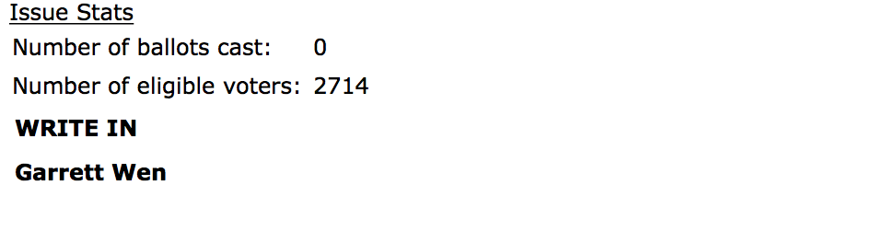

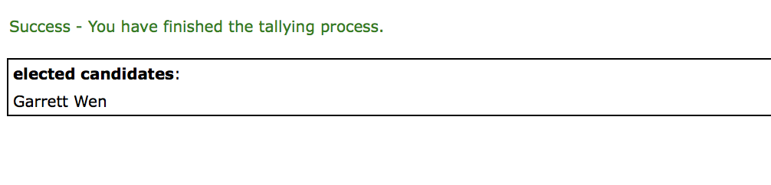

**WINTHROP**

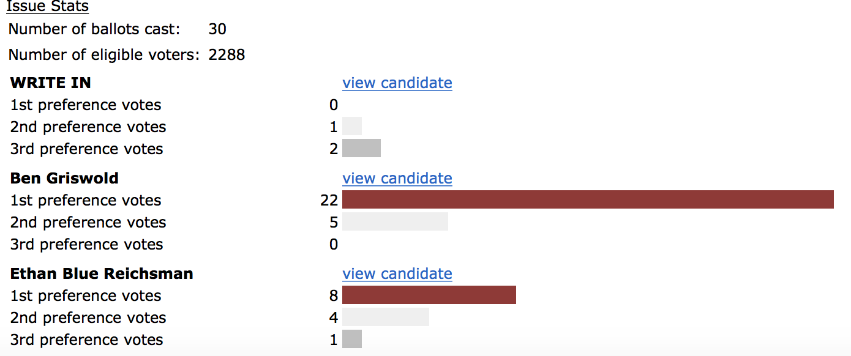

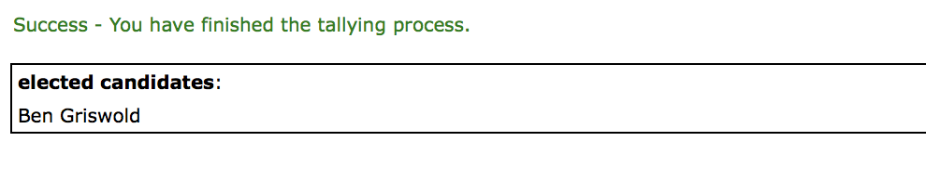

**ELM YARD**

